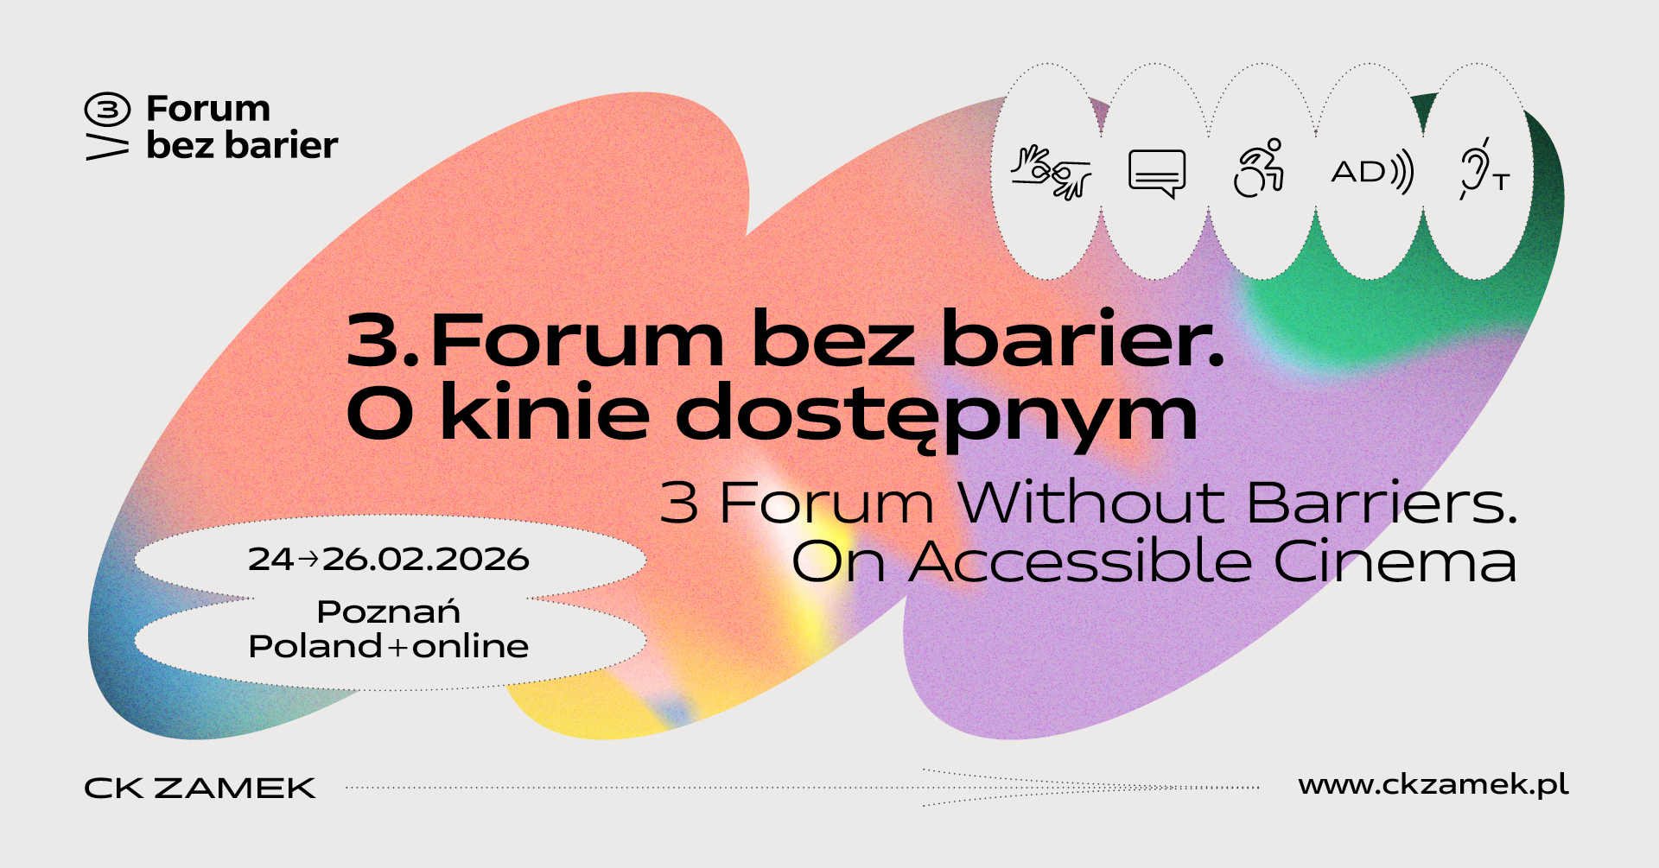

FORUM PRE-GUIDE

We are delighted to see you participate of the 3rd Forum Without Barriers! Below you will find the most important information on how to prepare for the event and what to expect once you arrive.
For the third time, Forum Without Barriers. On Accessible Cinema will bring together professionals involved in cinema services, distribution, production and film education, festival promoters, cultural institutions and technology providers. Together, we are going discuss the development of cinema that is open to the diverse needs of viewers. The programme will include workshops, conversations, presentations and expert meetings devoted to universal design of film events, representation of persons with disabilities in audiovisual productions, and the distribution of accessible films.

Forum Without Barriers is an inclusive event that welcomes all.
If you have any questions or concerns, please do not hesitate to contact us.
You will find contact details in the Contact section at the end of this Pre-Guide

1. This document contains information on the following:
- Location of the event and how to get there
- Information and Accreditation Point
- Rooms where the Forum events take place
→ List of rooms with a link to their location at ZAMEK Culture Centre.
- Forum accessibility
→ Summary of accessibility features at the venue.
- Programme of the Forum
→ Here you will find information about the Forum’s programme, a link to the website, as well as a summary of special events.
- Accommodation and partner discounts
→ List of recommended hotels and available discounts
- Environmental info
- Contact
→ List of persons who can help if you have any questions, along with their e-mail addresses and telephone numbers

2. Locations and How to Get There

ZAMEK Culture Centre in Poznań, also referred to as the Castle, is the main venue of the Forum
Address: ul. Święty Marcin 80/82
Google Maps link: https://goo.gl/maps/uMg3eZia9QFjsJvN8

Main Entrance / Entrance A
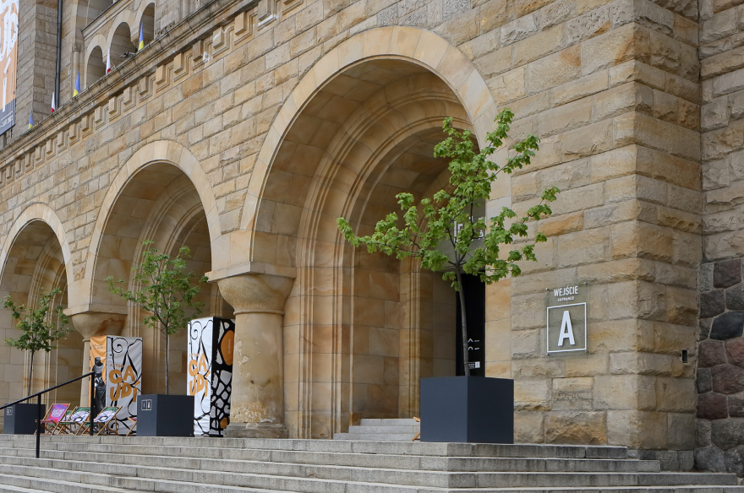
The doors open automatically thanks to motion sensors--just walk up to them and they will open.
Due to low temperatures during autumn and winter, two entrances remain open: the centre entrance and the side entrance on the left with the adjacent ramp. The right-hand entrance has a sign informing visitors that it is temporarily out of service.
Note: on entering the building, you will encounter another set of automatic doors. They operate just the same as the external doors. During the autumn and winter months, the open door is to the left, opposite the entrance with the ramp.
If you use a wheelchair or have difficulty climbing stairs, please use the ramp leading to Entrance A.

Entrance B
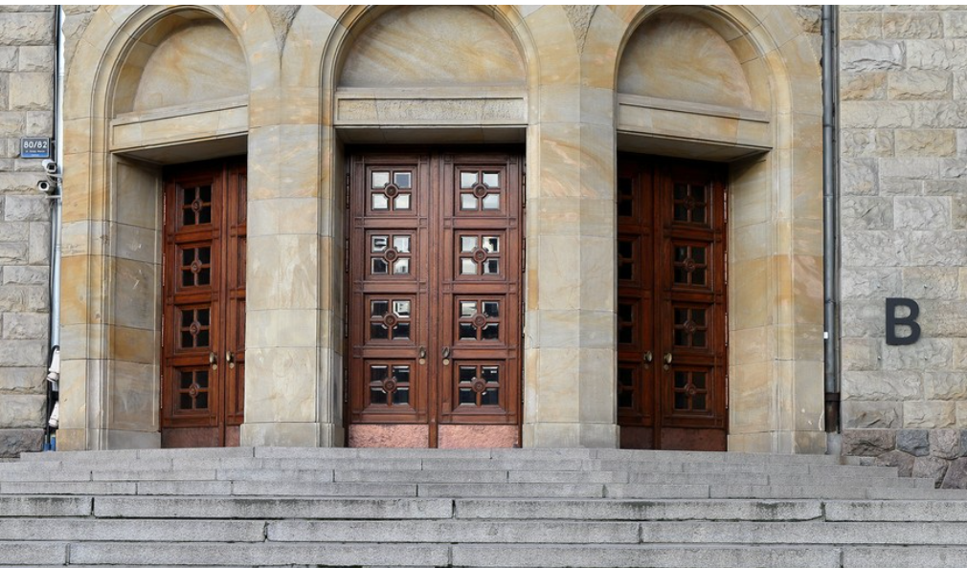
Entrance B is located in the Open Forecourt in front of ZAMEK Culture Centre (adjacent to Święty Marcin Street) and leads via stairs to the eastern part of the building. This entrance is less frequently used than the Main Entrance (Entrance A). There is no lift or platform for wheelchair users at Entrance B. On the left, there is a concierge desk where a wheelchair is available. Turn right towards the swing doors, then left towards the next swing doors. There, one the right you will find two lifts.

Access by public transport from the airport and railway station:

From Poznań-Ławica Airport (POZ) → ZAMEK Culture Centre in Poznań / City Centre
Buses no. 159, 148 (direction: Poznań Główny)

Board the bus at the “Port Lotniczy Ławica” stop, alight at the “Rondo Kaponiera” stop

From Rondo Kaponiera: walk down Święty Marcin Street (approx. 10 min) or take the tram to the “Zamek” stop. We recommend lines 13 (direction: Starołęka), 8 (direction: Miłostowo) and 3 (direction: Unii Lubelskiej). Rondo Kaponiera is a large interchange hub.

From the Poznań Główny railway station, → ZAMEK Culture Centre in Poznań / City Centre
Tram no. 5 (direction: Zawady), 6 (direction: Miłostowo), 12 (direction: Starołęka), alight at the “Zamek” stop
On foot: approx. 20 min through Karol Marcinkowski Park

Parking locations for persons with disabilities:
If you require a car and have a disability certificate, you can use the parking space marked with the PwD symbol. There is also a short-stay parking zone where passengers may get out and the driver may safely drive away after a while. The nearest such locations may be found on Kościuszki Street, near the main entrance to ZAMEK Culture Centre.
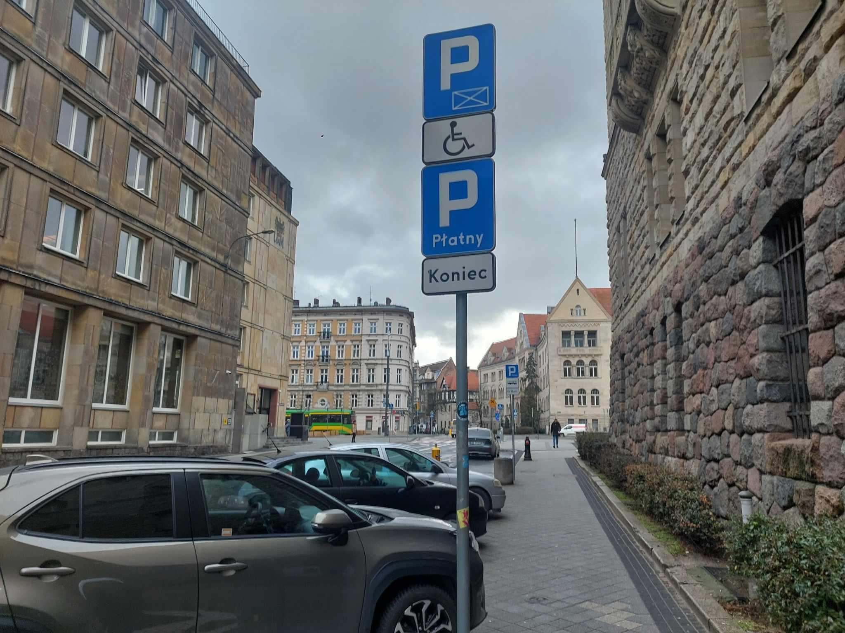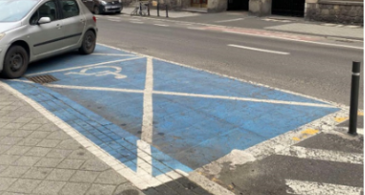

Bicycle parking

You can also come to events by bicycle! Bicycle racks are located at each entrance to ZAMEK Culture Centre.

Step-free entrance for wheelchair users
If you are unable to use the stairs:
- use the ramp leading to Entrance A
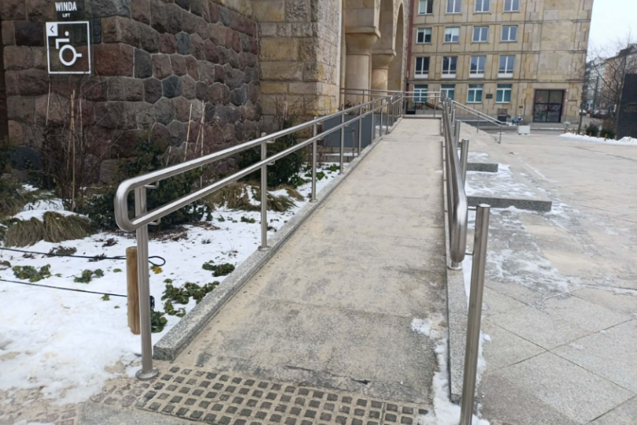
- or: enter ZAMEK Culture Centre through the Museum of the Poznań Uprising – June 1956 (whose entrance is marked with the number “1956”).
It is located on the left side of the main entrance to ZAMEK Culture Centre.
Inside the Museum, there is a lift for persons with mobility disabilities; the lift will take you to the ground floor. To enter the Grand Lobby at ZAMEK Culture Centre, you will have to go through the entrance doors. They are large and equipped with very strong actuators, which may make them difficult to open.
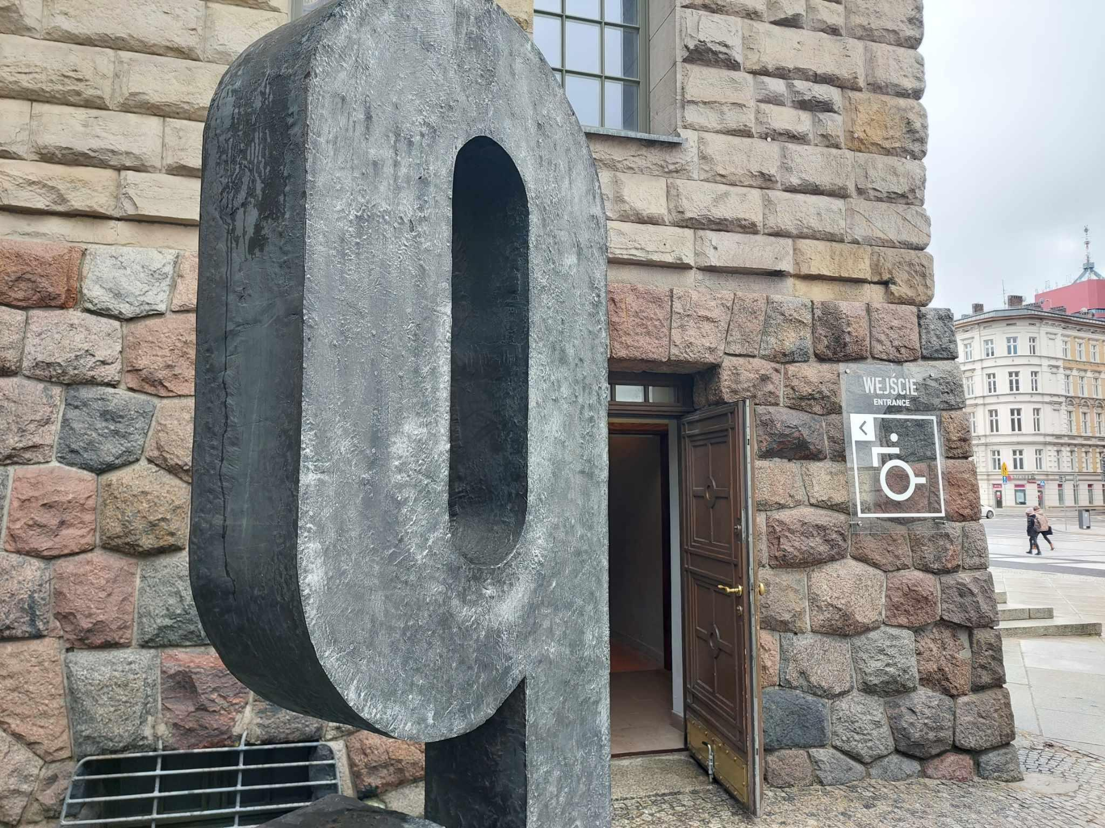

In the Grand Lobby, use the ramp next to the ticket office and head for the glass lift on your right.

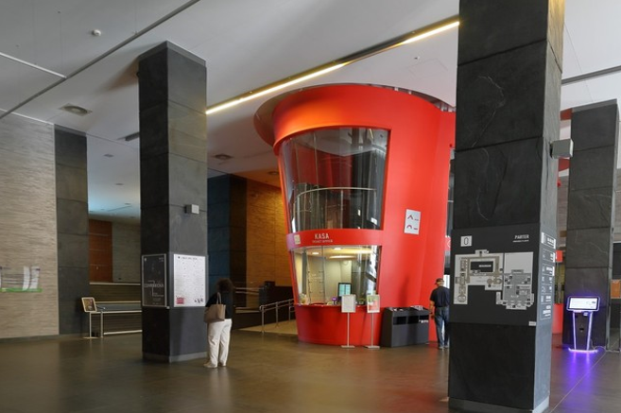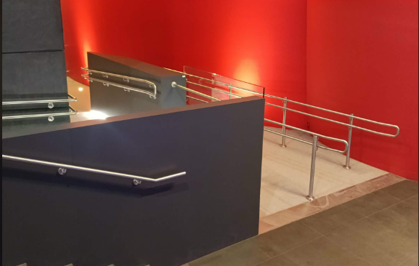
- Select the first floor. There, on the left, is the Grand Hall. The entrance route is also shown in the photos below:
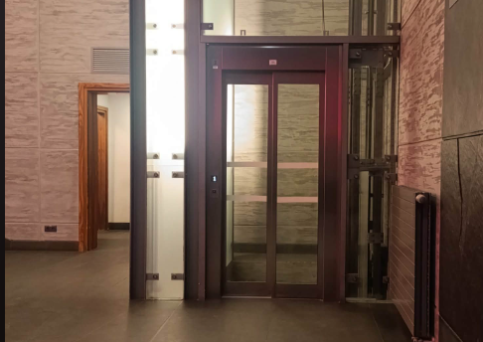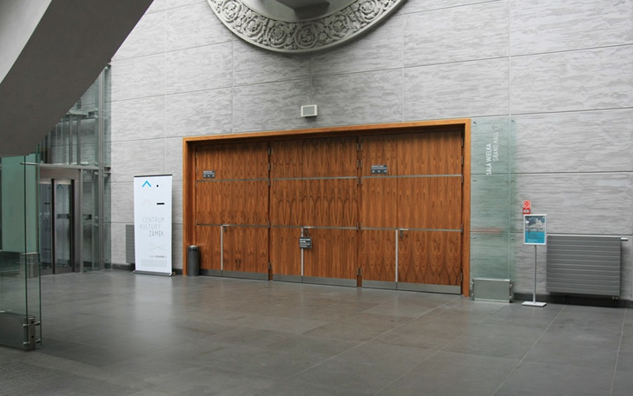

- To get to the West Wing (ground floor and other floors), use the ramp next to the ticket office and then the platform lift.
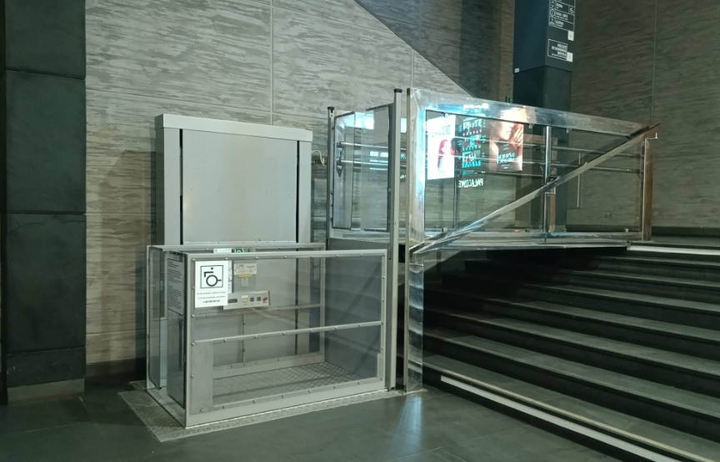
- Turn left and go through the door marked “Passage to the West Wing”’. To get to other floors, select one of the lifts
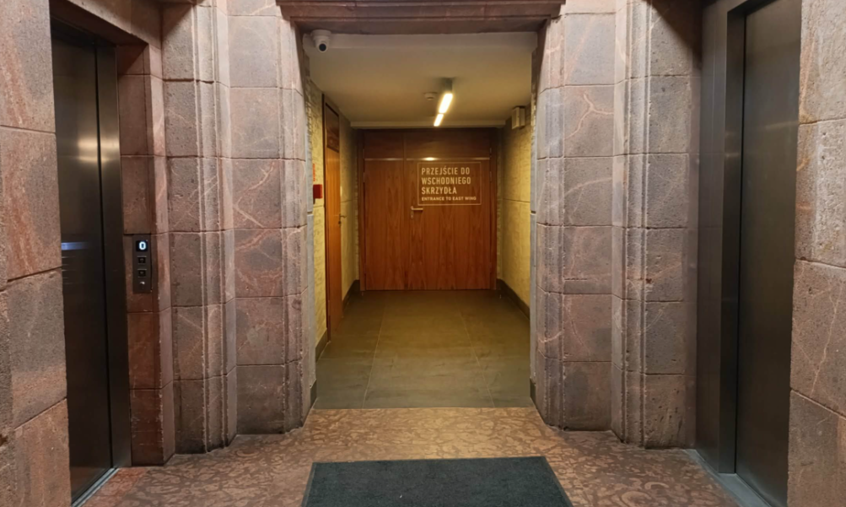

Cloakroom
The cloakroom is located in the Grand Lobby of ZAMEK Culture Centre behind the red ticket offices. It is there for you convenience, but you are not required to use it.

Opening hours:
- Tuesday (February 24th): from 5 p.m. to 10:15 p.m.
- Wednesday (February 25th): from 9:30 a.m. to 10:00 p.m.
- Thursday (February 26th): from 9:30 a.m. to 5:30 p.m.
Coat racks will be available in the workshop rooms.

3. Information and Accreditation Point

ZAMEK Culture Centre in Poznań
First floor, next to the Grand Hall
ul. Święty Marcin 80/82

Opening hours:
- Tuesday (February 24th): from 10:00 a.m. to 7:30 p.m.
- Wednesday (February 25th): from 9:00 a.m. to 6:30 p.m.
- Thursday (February 26th): from 9:00 a.m. to 3:00 p.m.
Here, you can ask us about the location of particular events, get directions within ZAMEK Culture Centre, or find out about the programme of the 3rd Forum Without Barriers. Also, this is where you will receive accreditation, Forum-related material, as well as detailed information about our events and transport in the city.

Admission to all Forum events is possible after purchasing accreditation:
https://3-forum-bez-barier-o-kinie-dostepnym.gridaly.com/registration

Contact person:
Maria Barańczyk
+48 512 207 744
If you have any questions, please contact Maria at m.baranczyk@ckzamek.pl

4. Forum Rooms

All rooms are located in the building of ZAMEK Culture Centre in Poznań, also referred to as the Castle.
During the events, aske persons with Forum Without Barriers badges if you require information.

How to get around ZAMEK Culture Centre (the Castle)?
Upon entering the building, you will find yourself in the new part of the Castle. On each floor, on the left-hand side, there is a passage to the West Wing.

Take advantage of a virtual tour of the Castle:
https://my.mpskin.com/pl/tour/centrum-kultury-zamek-skrzydlo-wschodnie

Assistance volunteers
Getting around the Castle can be challenging, so if you need any help getting to a room, please let us know at least one day before the event, i.e. by 10:00 a.m. on February 23rd. Please contact Maria Trzeciak at m.trzeciak@ckzamek.pl, or by phone or a text message to: 506 491 302.

List of rooms

Grand Hall
First floor → Access via an accessible entrance ramp and glass lift or stairs

Workshops
- Ash Room (117)
First floor, West Wing → Access via accessible entrance ramp, platform lift and lifts or stairs
- Room Under the Clock
Second floor, West Wing → Access via accessible entrance ramp, platform lift and lifts or stairs
- Meeting Room (55)
Ground floor, West Wing → Access via accessible entrance ramp and platform lift or stairs
- Laboratory 1 and Laboratory 3
Ground floor, West Wing → Access via accessible entrance ramp and platform lift or stairs

Catering area:
Coffee breaks and lunches with both higher and lower tables.
Hallway in front of the Room Under the Clock
Second floor, West Wing → Access via accessible entrance ramp, platform lift and lifts or stairs

One-to-one meetings with experts
Room Under the Clock
Second floor, West Wing → Access via accessible entrance ramp, platform lift and lifts or stairs

Quiet room

Barrel Room (304)
Third floor, West Wing → Access via accessible entrance ramp, platform lift and lifts or stairs
To get to the third floor, use either of the two facing lifts in the West Wing. After exiting the lift, step-free access to the Barrel Room leads through the corridor to the right, around the floor, following its layout. You can also use the stairs located to the left of the lifts. The room is located next to the letterboxes, in front of the glass doors.

Pałacowe Cinema
Cinema Without Barriers film screenings
First floor → Access via an accessible entrance ramp and glass lift or stairs

5. Accessibility of the Forum

Accessibility of the venue and its spaces
- The Forum venue and its spaces are adapted to the needs of wheelchair users.
- At ZAMEK Culture Centre, induction loops are available at all times at the ticket office, Pałacowe Cinema and Laboratory 1.
- The Grand Hall is equipped with portable induction loops. Please pick up a loop receiver before entering the hall.
- The café and bookstore on site are accessible to persons with alternative mobility.
- High and low tables will be available in the catering area.

Accessible toilets
- Toilets adapted to the needs of persons with mobility disabilities are located on the ground floor, first floor and second floor.
- Changing Place is located on the ground floor in the men's toilet, opposite the glass lift.

Quiet room
- The Barrel Room (304) on the third floor is our quiet space, prepared for those who need peace and a moment of relaxation.

Programme accessibility
- All events in the Grand Hall will be interpreted into Polish, English and Polish Sign Language (PSL).
- Events will be provided with Polish and English subtitles.
- Headphones for interpretation can be collected at the entrance to the Grand Hall.
- Volunteers can pick you up from the nearest bus or tram stop, show you the nearest toilet, or guide you to a particular room.
- Online participation:
If a participant cannot be present at the venue in person, they may take advantage of online participation in Polish and English, with translation into PSL and subtitles.

6. Programme of the Forum

The programme of the 3rd Forum Without Barriers. On Accessible Cinema may be found at:
https://ckzamek.pl/wydarzenia/13789-ogaszamy-program

Coffee breaks and lunch:
The hallway in front of the Room Under the Clock on the second floor is our catering area. Here, coffee, tea, water as well as plant-based and gluten-free specialities from Bo.Poznań, a local caterer, will be served during the scheduled breaks between events. Both low and high tables will be provided at the location.

Special events:
- Tuesday, February 24th, from 7:30 p.m. to 9:45 p.m.: Pałacowe Cinema (Room 1) will host an accessible screening of Nie ma duchów w mieszkaniu na Dobrej (There Are No Ghosts in the Apartment on Dobra Street), followed by a meeting with the filmmakers.
- Tuesday, February 24th, from 7:30 p.m. to 8:30 p.m.: guided tour of the Castle in Polish.
- Tuesday, February 24th, at 10:00 p.m.: Pub Quiz at the Forum club, The Dubliner Irish Pub. The Dubliner in located on our premises, with entrance from Aleja Niepodległości.
- Wednesday, February 25th, from 6:00 p.m. to 7:00 p.m.: guided tour of the Castle in English.
- Wednesday, February 25th, from 8:00 p.m. to 9:30 p.m.: awards gala of the 3rd Forum Without Barriers. On Accessible Cinema, combined with a screening of short features from the ReelAbilities Film Festival: New York

7. Accommodation and Partner Discounts
- Hotel Don Prestige Residency → lowest prices!
- Hotel Altus Old Town Poznań → 10% discount with the code ForumBezBarier
- B&B Hotel Old Town → 10% discount with the code ForumBezBarier
- NH Hotels → 10% discount with the code ForumBezBarier
- Hotel De Silva Poznań
- Hotel Pomarańczarnia
- Hotel Novotel Poznań Centrum
- Apart Avenue 22
- Poznań Apartments Towarowa

Click here for more information.

Show your Forum ID to receive discounts at the following locations:
- Cafe Poziom
ul. Święty Marcin 80/82 (2nd floor, mezzanine)
10% discount on the entire menu
- Ptasie Radio
ul. Kościuszki 74/3
15% discount on the entire menu
- Lokum Stonewall
ul. Fredry 7
20% discount on the entire menu
- KAFEDRAM
ul. Święty Marcin 80/82
10% discount on the entire menu
- Trzecia Kawa
ul. Polna 1
15% discount on the entire menu
- Perełka
ul. Ratajczaka 31
10% discount on the entire menu
- Vintage & Friends
ul. Zwierzyniecka 15
10% discount on the entire range
- Wy.Szukane Concept Store
ul. Podgórna 8
10% discount on the entire range
- Cafe Bajka
Stary Rynek 25
10% discount on cake + coffee/tea (excluding the set of the day) and hot chocolate
- Kawiarnia Kociak
ul. Święty Marcin 26
10% discount on cake + coffee/tea (excluding the set of the day) and hot chocolate

Click here for more information.

8. Environmental Info

- Bring a water bottle with you—the water from the taps at ZAMEK Culture Centre is perfectly safe to drink!
- Use a bag from previous events or purchase a mesh bag from ZAMEK’s shop.
- Take advantage of the vegan catering available at the Forum—it is delicious, plant-based and planet-friendly.
- Waste segregation is practised at the Forum. There are appropriately marked bins in many places, and we encourage you to use the designated containers.
- After certain hours, the lighting in selected locations on our premises is turned off to reduce energy consumption.

9. Contact

Accessibility

Ewelina Banaszek
+48 607 609 038
If you have any questions regarding accessibility at our event, please contact Ewelina at e.banaszek@ckzamek.pl

Forum Office / Accommodation:

Maria Barańczyk
+48 512 207 744
If you have any questions regarding accreditation, please contact Maria at m.baranczyk@ckzamek.pl

Assistance and Volunteer Services

Maria Trzeciak
+48 506 491 302
If you have any questions regarding assistance or volunteer services, please contact Maria at m.trzeciak@ckzamek.pl.

